**Exercises:**

This is a following question of exercise 1. This time you have an exist txt file(student.txt) and we Want to read the whole line each time into a string and output the string. Using a while loop to keep reading records and counting the amount of records until the end of file. I have uploaded the student.txt file in this exercise folder. You can download this file or create one by yourself, then put it in the same folder of your project.

*Try to use getline function to read the whole line each time and store in a string variable.

*To count the amount of student’s name. You may need a counter to keep counting the number in the while loop.

Student.txt file loop like: (you can download from the same folder of exercise on github)

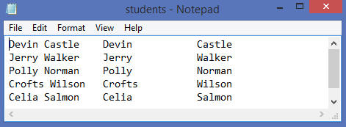

Sample output:

